AIR QUALITY MONITORING

USING IOT

S.Ajay

au812921106003

sajaysajay5799@gmail.com

INNOVATION

***Data collection:***

Thirty years ago, measuring smog levels could be a real headache.

Ozone measuring instruments demanded constant baby-sitting and frequently leaked chemicals so caustic that they etched the concrete floors and dissolved the plaster walls of monitoring stations. Vacuum pumps clattered constantly.

"It was like working in a factory. Those pumps were really noisy," said William Bope, AQMD's air quality monitoring manager.

Technicians had to fill the refrigerator-sized machines with wet chemical solutions that reacted with ozone and turned colors, providing a means for gauging the pollutant's levels. When a machine's plumbing backed up during a weekend, workers would arrive on Monday morning to a floor flooded with acid solutions. The finicky devices also needed constant adjustment

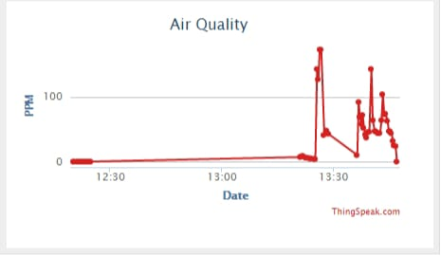

"You'd sneeze and the darn thing would be out of calibration," Bope said.

Today, an ozone monitor can fit into a large briefcase. Using only ultraviolet light and solid-state electronics, the silent devices can measure smog levels continuously, with little maintenance.

Scientists started developing air pollution monitoring devices in the late 1940s. Since little was known about the chemical nature of smog, and it had never before been measured, they had to start from scratch.

The first reliable field monitoring technique measured ozone levels based on the amount of time it took for the pollutant to crack a thin strip of rubber. As a vacuum pump drew a measured amount of outdoor air across a folded strip of rubber, a technician with a stopwatch and a magnifying eyepiece timed how long it took for the rubber to crack.

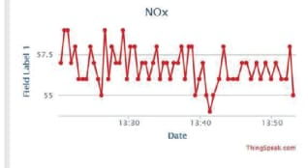

In 1955, the Los Angeles APCD established an alert system to warn the public and curtail or shut down industrial activity in the event of an impending air pollution emergency. The following year, APCD officials finished installing a 15-station monitoring network, the first in the nation to provide continuous air quality data for measuring and forecasting smog levels.

That system grew into today's network of more than 30 stations, which is the backbone for making daily forecasts, issuing health advisories, gauging long-term progress in reducing smog levels and developing air quality models to predict future attainment of clean air standards.

